Adding Decimals
To add decimal follow the below steps:
● Write down the decimal numbers, one number under the other number and line up the decimal points.
● Convert the given decimals to like decimals.
● Arrange the addends in such a way that the digits of the same place are in the same column.
● Add the numbers from right as we carry addition usually.
● Remember to place the decimal point down in the answer in the same place as the numbers above it.
1. Add the decimals:
(i) 1.83, 21.105, 236.8 and 0.9
Solution:
We have 1.83 + 21.105 + 236.8 + 0.9
Converting all the addends to like decimals
1)1.830 + 21.105 + 236.800 + 0.900
Arranging the addends in columns and on adding we get
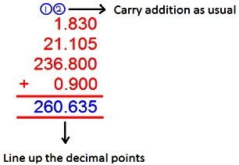
0Save
2) 7.39, 65.007, 213.8 and 91.2
Solution:
We have 7.39 + 65.007 + 213.8 + 91.2
Converting all the addends to like decimals
7.390 + 65.007 + 213.800 + 91.200
Arranging the addends in columns and on adding we get
